**Econometric Homework 3**

0613404 陸恭葦

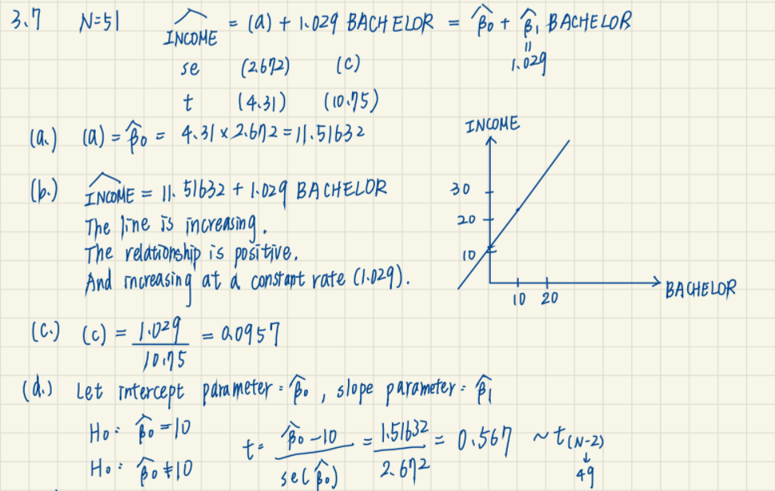

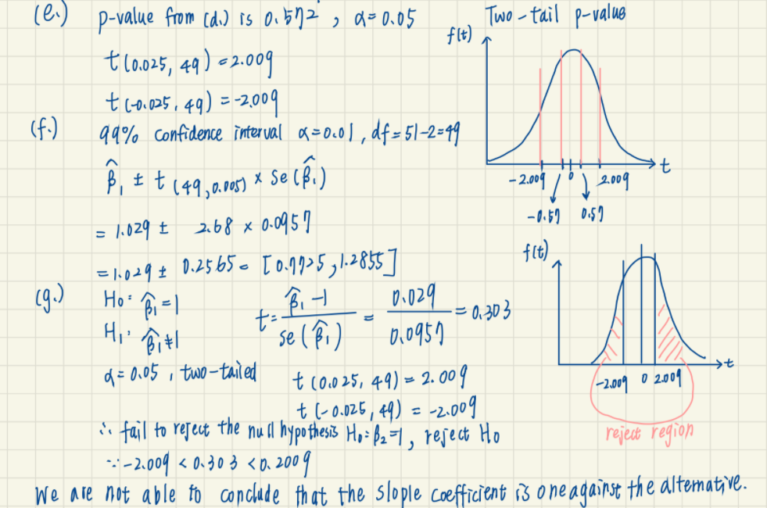

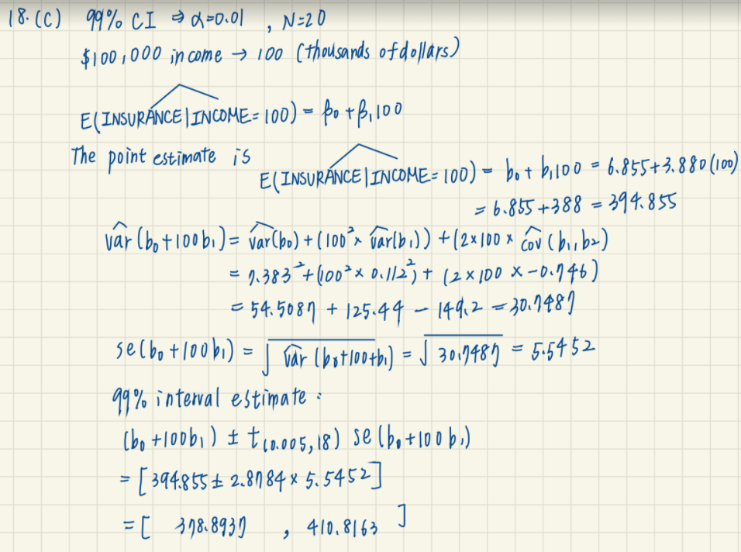

3.26

(a) Estimate the linear regression $WAGE=β_{1}+β_{2}EXPER+e$

We can find that the p-value of intercept and exper are all significant. However, the R-squared of the estimator is small.

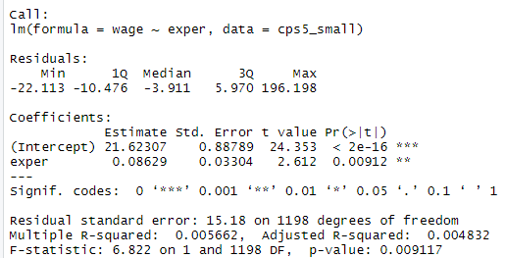

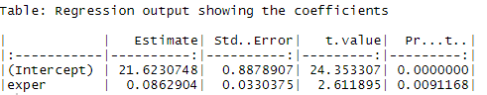

|  |
| --- |
| Rcode |
| mod <- lm(wage~exper,data = cps5_small)  smod <- summary(mod)  smod  SStable <- data.frame(xtable(mod))  kable(table, caption="Regression output showing the coefficients") |

(b)

I test right-tailed and left-tailed test with $∝=0.05$ and calculate t and tcr(t critical value),then conclude the result below:

|  |  |
| --- | --- |
|  |  |
| The result if the right-tailed test | He result od the left-tailed test |
| $$H_{0}: β_{2}≥0$$ $$H_{1}: β_{2}<0$$ | $$H_{0}: β_{2}≤0$$ $$H_{1}: β_{2}>0$$ |
| tcr<t | t<tcr |
| Reject $H_{0}$ | Reject $H_{0}$ |
| We are able to conclude that each additional exper (potential experience) will increase the wage. | |

|  |
| --- |
| Rcode |
| b2 <- coef(mod)[[2]] # the coefficient on exper  seb <- sqrt(vcov(mod)[2,2]) #standard error of b2  df0 <- df.residual(mod) # degrees of freedom  c <- 0  alpha <- 0.05  # one tail test  t <- (b2-c)/seb  tcr <- qt(1-alpha, df0) # note: alpha is not divided by 2  t01 <- (b2-c)/seb  tcr01 <- qt(alpha, df0)  curve(dt(x, df0), from = -5, to = 5, col = "orange",  xlab = "quantile", ylab = "density", lwd = 2)  abline(v=c(tcr,t), col=c("red", "blue"), lty=c(2, 3))  legend("topleft", legend=c("tcr", "t"), col=c("red", "blue"), lty=c(2, 3))  curve(dt(x, df0), from = -5, to = 5, col = "orange",  xlab = "quantile", ylab = "density", lwd = 2)  abline(v=c(tcr01,-t01), col=c("red", "blue"), lty=c(2, 3))  legend("topleft", legend=c("tcr", "t"), col=c("red", "blue"), lty=c(2, 3)) |

(c) Estimate the linear regression $WAGE=β_{1}+β_{2}EXPER+e and METRO=1$

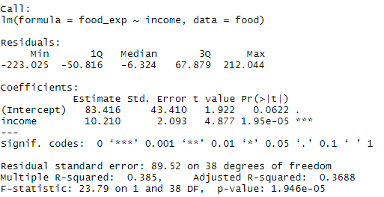

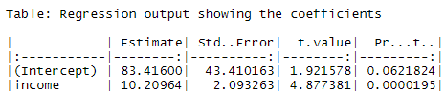

Then,I test right-tailed test with $∝=0.01$ and calculate t and tcr(t critical value),then conclude the result below:

|  |
| --- |
|  |
| The result if the right-tailed test |
| $$H_{0}: β_{2}≥0$$ $$H_{1}: β_{2}<0$$ |
| tcr<t |
| Reject $H_{0}$ |
| We are able to conclude that each additional exper (potential experience) in metropolitan area will increase the wage. |

The effect here is significant because we get the similar result with (b). We can conclude each additional exper (potential experience) in metropolitan area will increase the wage.

|  |
| --- |
| Rcode |
| totoal <-which(cps5_small$metro==1)  cps2<-cps5_small[total,]  mod1 <- lm(wage~exper,data = cps2)  #mod1  smod1 <- summary(mod1)  #smod1  table <- data.frame(xtable(mod1))  kable(table, caption="Regression output showing the coefficients")  b22 <- coef(mod1)[[2]] # the coefficient on exper  seb1 <- sqrt(vcov(mod1)[2,2]) #standard error of b2  df1 <- df.residual(mod1) # degrees of freedom  c <- 0  alpha <- 0.01  # one tail test  t1 <- (b22-c)/seb1  tcr1 <- qt(1-alpha, df1) # note: alpha is not divided by 2  curve(dt(x, df1), from = -5, to = 5, col = "orange",  xlab = "quantile", ylab = "density", lwd = 2)  abline(v=c(tcr1,t1), col=c("red", "blue"), lty=c(2, 3))  legend("topleft", legend=c("tcr", "t"), col=c("red", "blue"), lty=c(2, 3)) |

(d) Estimate the linear regression $WAGE=β_{1}+β_{2}EXPER+e and METRO=0$

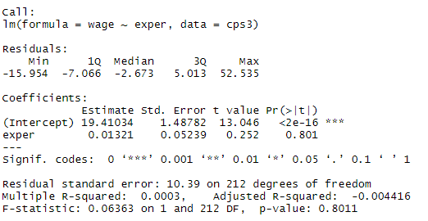

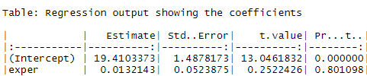

Then,I test right-tailed test with $∝=0.01$ and calculate t and tcr(t critical value),then conclude the result below:

|  |
| --- |
|  |
| The result if the right-tailed test |
| $$H_{0}: β_{2}≥0$$ $$H_{1}: β_{2}<0$$ |
| t<tcr |
| Don’t reject $H_{0}$ |
| We are not able to conclude that each additional exper (potential experience) in nonmetropolitan area will increase the wage. |

From the result above, we can’t safely say that experience has no effect on wages for individuals living in nonmetropolitan areas because we reject $H_{0}$. There is not sufficient evidence to make sure the relation between experience in nonmetropolitan and wage.

|  |
| --- |
| Rcode |
| total2 <-which(cps5_small$metro==0)  cps3<-cps5_small[total2,]  mod2 <- lm(wage~exper,data = cps3)  smod2 <- summary(mod2)  smod2  table <- data.frame(xtable(mod2))  kable(table, caption="Regression output showing the coefficients")  b23 <- coef(mod2)[[2]] # the coefficient on exper  seb2 <- sqrt(vcov(mod2)[2,2]) #standard error of b2  df2 <- df.residual(mod2) # degrees of freedom  c <- 0  alpha <- 0.01  # one tail test  t2 <- (b23-c)/seb2  tcr2 <- qt(1-alpha, df2) # note: alpha is not divided by 2  curve(dt(x, df2), from = -5, to = 5, col = "orange",  xlab = "quantile", ylab = "density", lwd = 2)  abline(v=c(tcr2,t2), col=c("red", "blue"), lty=c(2, 3))  legend("topleft", legend=c("tcr", "t"), col=c("red", "blue"), lty=c(2, 3)) |